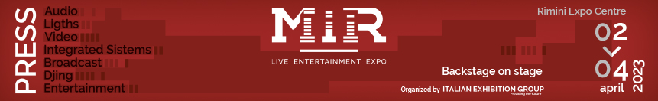

press release
(English translation)

IEG: MIR RETURNS TO RIMINI, FROM 2nd TO 4th APRIL 2023

- It is the only Italian trade show dedicated to technologies and services for music
- An increasingly contemporary, stimulating and "integrated" format
- The 6th edition, again at Rimini Expo Centre, with a global experience

Rimini (Italy), July 20th 2022 - Italian Exhibition Group announces the new dates of MIR, the only Italian exhibition dedicated to the entire Light, Sound, Visual, Integrated System & Broadcast supply chain, which will be held from 2 to 4 April 2023, as always at Rimini Expo Centre.

The success of MIR's three-day Rimini event last March, the first European event in the sector after the pandemic, confirmed the event as the reference platform for professionals in the sector, catalyzing the consensus of operators and allowing strengthen a closer relationship with institutions and trade associations.

The next edition of MIR will be much more than an exhibition, where to get to know the major players and the latest market news, it will represent the only Italian event of international scope, able to offer a complete experience on advanced technologies and solutions for entertainment. With a rich schedule of quality events and workshops, facilitating networking moments and business opportunities necessary for all professionals.

The MIR format constitutes the strong point of the project, increasingly contemporary, stimulating and “integrated”. With live and digital shows, presentations of innovative solutions and systems for different types of shows and the participation of many specialized professionals, because the theme of integrating new technologies represents the future and the continuous expansion of the entire sector.

ABOUT MIR 2023
Date: 2-4 April 2023; organizer: Italian Exhibition Group SpA; edition: 6th; frequency: annual; info: https://www.musicinsiderimini.it/

FOCUS ON ITALIAN EXHIBITION GROUP
Italian Exhibition Group S.p.A., a joint stock company listed on Euronext Milan, a regulated market organised and managed by Borsa Italiana S.p.A., has, with its facilities in Rimini and Vicenza, achieved national leadership over the years in the organisation of trade shows and conferences. The development of activities abroad - also through joint-ventures with global or local organisers, in the United States, United Arab Emirates, China, Mexico, Brazil and India, for example - now sees the company positioned among the top European operators in the sector.

PRESS CONTACT media@iegexpo.it

This press release contains forecast elements and estimates that reflect the management’s current opinions (“forward-looking statements”), particularly regarding future management performance, realization of investments, cash flow trends and the evolution of the financial structure. For their very nature, forward-looking statements have a component of risk and uncertainty, as they depend on the occurrence of future events. The effective results may differ (even significantly) from those announced, due to numerous factors, including, only by way of example: food service market and tourist flow trends in Italy, gold and jewellery market trends, green economy market trends; the evolution of raw material prices; general macroeconomic conditions; geopolitical factors and evolutions in the legislative framework. Moreover, the information contained in this release does not claim to be complete, and has not been verified by independent third parties. Forecasts, estimates and objectives contained herein are based on the information available to the Company as at the date of this release.

